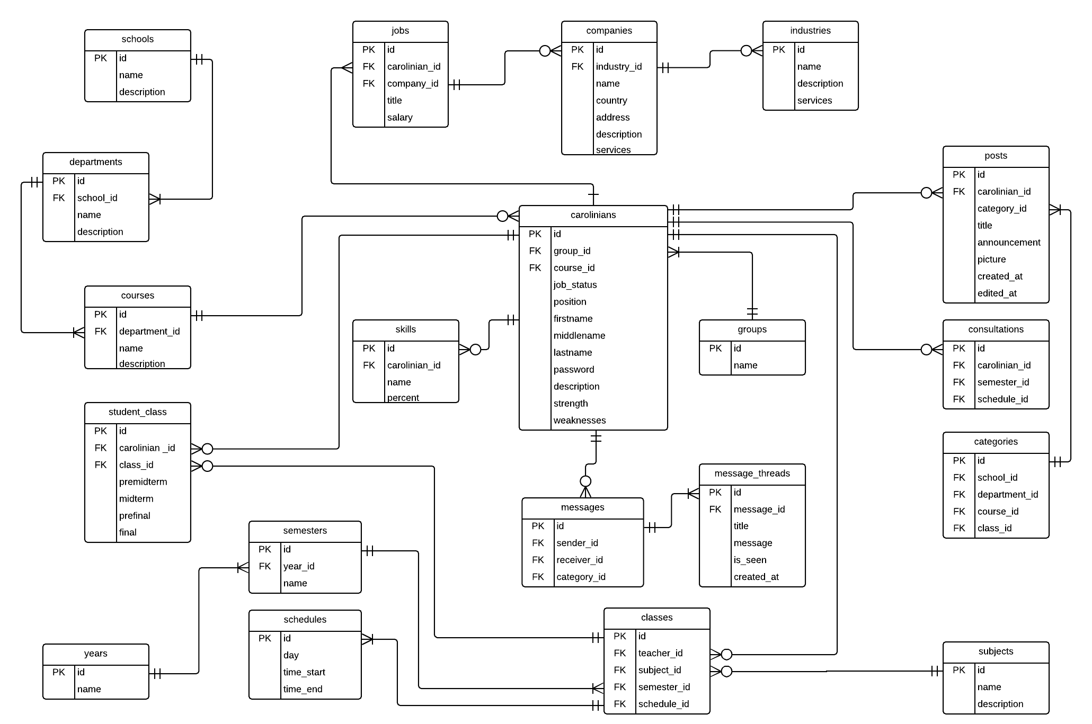

**Database Documentation of USC-RECONNECT:**

*Legends*

1. **Bold** – these are the table names of the database
2. Underline – these are the fields of the database.
3. (Parenthesis) – Enclosed are the data type and data example of the field. Format (Data Type: “Data Type Name”. “Example Data”).

*Tables*

**Carolinians** – are all the users of our system. This contains their most important information details relevant to the system.

* Job Status occurs when a carolinian’s group is Alumni and is employed or unemployed (Data Type: Tiny Int. 0-Unemployed and 1-Employed).
* Position occurs when a carolinian’s group is Teacher (Data Type: Varchar. Faculty, Teacher, Part-Time Teacher, and etc).
* Description holds a short bio of the User (Data Type: Varchar. I am a boy and I like sushi and mathematics).
* Strength holds the list of strengths of the carolinian user (Data Type: Set. Group Leader, Financing, Time-Management).
* Weaknesses holds the list of weaknesses of the carolinian user (Data Type: Set. Laziness, Unmotivated, Procrastinating).

**Groups** – are all the groups that clasify the type of user.

* Name clasify the user ONLY with Student, Alumni, Teacher, Admin (Data Type: Enum. Admin) .

**Skills** – are the skills a user has.

* Name tells the name of the skill of the user (Data Type: Varchar. Photoshop).
* Percent ranks the skill of the user on how experienced the user is on that skill (Data Type: Int. 50) #Note: Percent is from 1-100 only.

**Messages** – are the contacts that carolinian messages.

* Sender is the first who initiated the message conversation (Data Type: Int Foreign Key.).
* Receiver is the one being messaged on the conversation (Data Type: Int Foreign Key.).
* Category is links to the category *table* connected to post. I didn’t connect Message *table* and Category *table* cause they won’t reach ☹ (Data Type: Int Foreign Key).

**Message_Threads** – are the messages of a specific contact.

* Title is simply the title of the message thread. Users must have a title every time they message (Data Type: Varchar. Question on the deadline of submissions).
* Message is the body of the message (Data Type: Varchar. Sir Baguio, when is the deadline of our jumping jacks assignment?).

**Courses** – occurs when the user is either a student or alumni. These are all the courses of the USC.

* Name tells the name of the course (Data Type: Varchar. Information and Communications Technology).
* Description tells the course descripton (Data Type: Varchar. Information and Communications Course for you etc).

**Departments** – are all the departments of USC.

* Name tells the name of the department (Data Type: Varchar. Department of Computer and Information Sciences).
* Description tells the department description (Data Type: Varchar. Handles ICT, IT, and CS or any computer related courses).

**Schools** – are all the schools of USC.

* Name tells the name of the school (Data Type: Varchar. School of Arts and Sciences(SAS)).
* Description tells the school description (Data Type: Varchar. Arts and Sciences related departments).

**Student Class** – this table is separated to track each student’s class and each class’s student with their corresponding grade.

**Classes** – are all the classes.

* Teacher is a carolinian id which is an id with a group of teacher (Data Type: Int Foreign Key.).

**Subjects** – are all the subjects of USC.

* Name tells the name of the subject (Data Type: Varchar. History 17).
* Description tells the description of the subject (Data Type Varchar. Introduction to the History of Jose Rizal).

**Schedules** – are the schedules of a specific class.

* Day tells which day of the week (Data Type: Varchar. Monday).
* Time Start tells when will the subject start (Data Type: Time. 15:00).
* Time End tells when will the subject ends (Data Type: Time. 16:30).

**Semesters** – are all the semesters recorded by the system.

* Name tells the name of the semester (Data Type: Varchar. Trisemster).

**Years** – are all the years recorded by the system.

* Name tells the name of the year (Data Type: Int. 2018).

**Jobs** – occurs when their group are alumni and these are their jobs.

* Title is your job title (Data Type: Varchar. Front- End Web Developer).
* Salary is the pay from their job (Data Type: Float. 100000.00)

**Companies** – are all the companies mostly commonly employed by alumni.

* Name tells the name of the company (Data Type: Varchar. Lite Technology).
* Country tells which country the alumni is employed (Data Type: Varchar. Philippines).
* Address tells the address of the company (Data Type: Varchar. Talamban, Nasipit).
* Description tells the company description (Data Type: Varchar. This company makes computer programs for small business).
* Services tells the services of the company (Data Type: Set. Programming, Graphic Design, Coding).

**Industries** – are all the industries recorded by the system.

* Name tells the name of the industry (Data Type: Varchar. Human Resource).
* Description tells the description of the industry (Data Type: Varchar. Handles human interactions between customer and company).
* Services tells what kind of services specifically this industry handle (Data Type: Set. Training, Hiring, Administration).

**Posts** – the all the announcements of the posted on this system. Available to Alumni, Teachers and Admin.

* Title tells the title of the post (Data Type: Varchar. Intramurals First-Day Schedule).
* Announcement is the body of the post (Data Type: Varchar. 8:00-9:00 pm is the general assembly at the gym).
* Picture shows the proof of announcement/ infographic or social graphic (Data Type: Blob/Varchar(File Directory). ‘Picture’).
* Created At and Edited At are date and time of announcements (Data Type: datatime.).

**Categories** – are the categories used in filtering in the application.

* School, Deparment, Course, and Class are connected with their corresponding *tables*.

**Consultations** – are the times when a teacher is available for consultations

* Semester and Schedule are connected with *tables* Semesters and Schedules.